FOR IMMEDIATE RELEASE
CONTACT: Jim Farrell, PR First, 781-681-6616, jfarrell@prfirst.com

Alba Med Spa LLC welcomed to Weymouth by state, business leaders at November 29 ribbon-cutting

WEYMOUTH, MA, ISSUED DECEMBER 2, 2018…Alba Med Spa LLC (www.albamedspa.com) owners James and Pam Kirby of Whitman received a warm welcome from a number of state and civic leaders at their ribbon-cutting ceremony held November 29 at their new location, 1221 Main Street, Suite 203-B in South Weymouth.

State Senator Patrick O’Connor and his Chief of Staff, Gregory Denton, were among the guests who welcomed the Kirbys and their new business to Weymouth. Senator O’Connor read a proclamation issued by the Massachusetts State Senate, congratulating the couple on their new business venture. He also presented a similar citation from the Massachusetts House of Representatives, from State Representative Majority Leader Ronald Mariano and State Representative James Murphy.

Also on hand were South Shore Chamber of Commerce CEO Peter Forman and Membership Relations Manager Tammie Heinrichs. They were also joined by Weymouth Chamber of Commerce Chair Dennis Keohane.

The Kirbys also had support from the Veterans Business Owners’ Association; on hand to congratulate them on their new venture were Elizabeth Riley, Jerry Pinsky, Altes J. Durand, and Ernie Smith.

“We also plan hours that are convenient to the average person, including Saturday and Sunday hours by appointment,” said James “Jamie” Kirby, a retired Captain in the Army Reserves Nurses Corps., who served 21 years and has worked as a Staff Nurse at Boston Medical Center since 2005. Kirby holds a Masters Degree as a Family Nurse Practitioner from the University of Massachusetts/Boston as well as a Bachelor of Science in Nursing also from the University of Massachusetts.

Services offered at Alba Med Spa will include; Laser carbon facials, cosmetic injection, platelet rich Fibrin, laser and intense pulse light (IPL) treatments for treatment of spider veins,“sun spots,” rosacea and skin rejuvenation, laser tattoo, hair and toe nail fungus removal. Micro-needling and alopecia treatment. Consultation is required by an Alba Med Spa LLC licensed medical professional prior to any treatments.

Alba Med Spa is a member of the Veterans Business Owners Association, the American Med Spa Association and the South Shore Chamber of Commerce. He is a member of the American Nurses Association, American Association of Nurse Practitioners, Certified Medical Surgical Registered Nurse through American Nurses Credentialing Center, Mass Coalition of Nurse Practitioners, and a graduate of National Laser Institute.

“We are very excited about this new venture,” said Pam Kirby, adding, “This is an up-and-coming field, and we are looking forward to offering our services to the people of this region. We believe that our knowledge and our commitment to perfection set us apart.”

About Alba Med Spa
Founded by James and Pam Kirby, Alba Med Spa offers a wide range of beautification, cosmetic and aesthetic treatments, including Botox®, Hyaluronic acid dermal fillers, skin rejuvenation through laser and IPL treatments, tattoo removal, laser and intense light pulse treatments, tattoo reduction and laser toe nail fungus removal. The platelet rich fibrin treatments that they will provide is an advanced form of platelet rich plasma that is offered by other aesthetic clinics in the area. Alba has plans to expand their services to include PDO threads (non-surgical face lift) in the near future.

Alba Med Spa is located at 1221 Main Street, Suite 203-B, South Weymouth, Massachusetts 02190. For more information, please call 774-257-5155 or visit www.albamedspa.com. Email Office@AlbaMedSpa.com

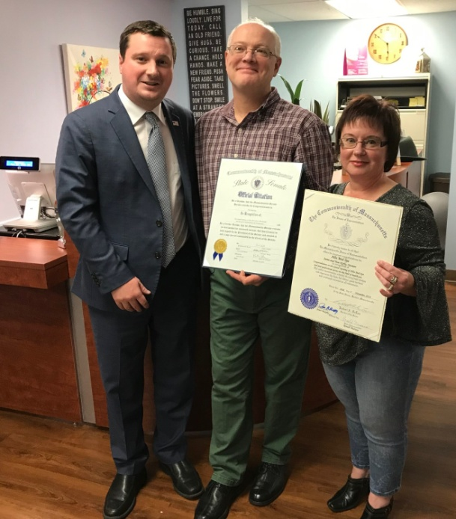

Photos: State Senator Patrick O’Connor (left) is shown with Jamie (center) and Pam Kirby of Whitman, who recently opened Alba Med Spa in Weymouth. Senator O’Connor presented commendations from both the Massachusetts State Senate and Massachusetts House of Representatives to congratulate the husband and wife on their new business venture.

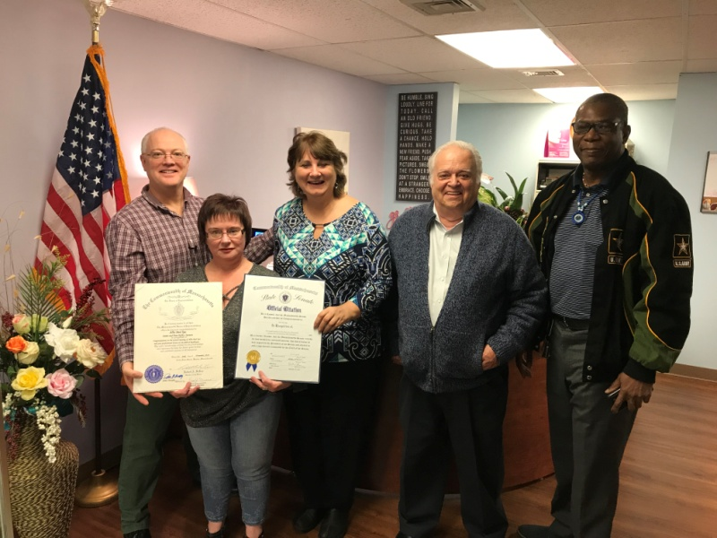
Veteran support: Jamie Kirby (far left), a retired Army Captain and owner of Alba Med Spa along with his wife Pam (second from left) are congratulated by members of the Veterans Business Owners Association including Elizabeth Riley, Jerry Pinsky, and Altes Durand. Alba Med Spa hosted its Grand Opening/Ribbon Cutting ceremony November 29 at their new location, 1221 Main Street, Weymouth.

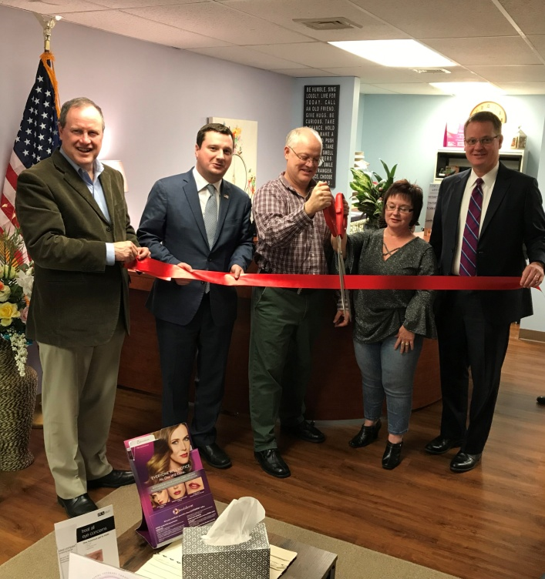

Ribbon cutting: Alba Med Spa owners Jamie and Pam Kirby (third and fourth from left in this photo) were joined in a ribbon-cutting ceremony November 29 for the opening of Alba Med Spa, 1221 Main Street, Weymouth. Left to right: Peter Forman, CEO, South Shore Chamber of Commerce; Senator Patrick O’Connor, Jamie and Pam Kirby, and Dennis Keohane, Chair of the Weymouth Chamber of Commerce.

